- When you go to: http://marylandlearninglinks.org/950,  Click on UDL Interactive Activity | 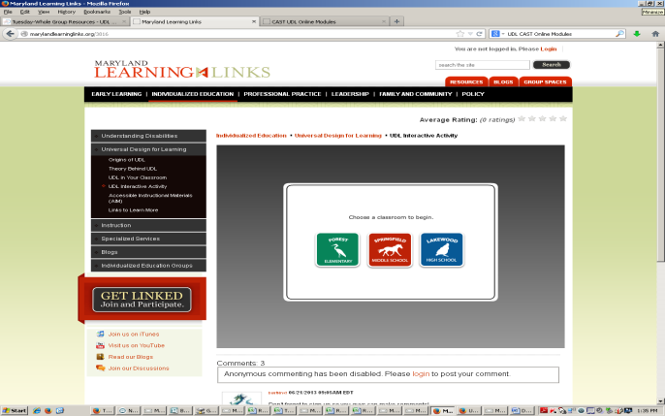  - Select level of education (Elem, MS, HS)
- Work through the Interactive Activity to:  Provide practice in applying UDL principles when developing goals, instructional delivery methods, material selections, and assessment. Examples provided are not crated to represent exemplar lesson development, but as a means to practice using UDL principles in each area. | - Consider reflecting on learning materials and methods that can be a part of the daily learning environment.  What do you think a teacher can have available daily to all students?

